

cloud computing project

ENG. Sara Eldesouky



martin maher 22010445

youssef ahmed ragaee 2202126

Ahmed Yasser 2201055

Youssef Tamer Mohammed Ahmed 2206172

“**Here we pull the mysql image from the docker hub”**

**“we run a mysql server container with password:martin and the (-d )is to make the container run in the background”**

**“the mysql server container we created”**



**“creating an client container”**



**“Both of the server container (exciting_matsumoto) and the client container(hungry_robinson)**



**“We inspect the server container in order to find it’s IP”**



**“The sever’s container IP”**

**“connecting both the client and the server together using the sever’s IP”**

**“the mysql dataset”**

**“running the php image and also forwarding the port from 8080 to 80”**

**“the result of running the phpMyAdmin command but there is no way for connecting it with the server container containing the dataset”**

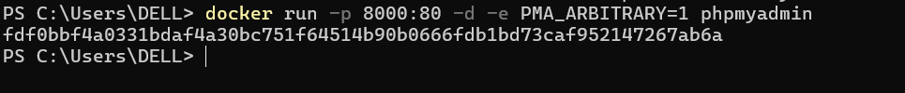

**“here we can connect both of the containers using the server container IP”**

**“the IP:”**

**“There is the students2 dataset”**